VICTORIAN TAXI GOLF ASSOCIATION INC.

PRESENTS THE 39th AUSTRALIAN

TAXI GOLF CHAMPIONSHIPS

5th MARCH - 11th MARCH 2023

CURLEWIS - VICTORIA

The 18 hole, Par 71 championship course consistently rates as one of the finest in regional Victoria.

(Ranked 25th in public access courses in Australia. (March 2022))

When it comes to facilities, functions and epicurean experience, the new Curlewis Clubhouse is next level.

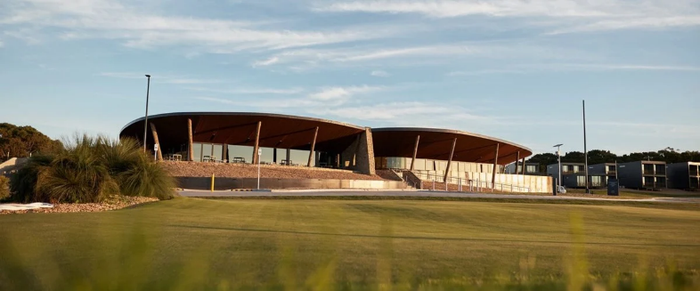 Add to that an accommodation complex on course, like no other and able to sleep up to 120.

***CHAMPIONSHIP INFORMATION***

***(subject to change)***

Australian Taxi Golf Association Championships. Three rounds of ATGC stroke play OR Three rounds of non ATGC Stableford scoring.

Australian Taxi Golf Association Ladies Rose Bowl Championship.

Two Rounds of stroke play with a final day of social competition.

***Join us at Curlewis golf club for four rounds of comradery and competition.***

# Matches played in groups of four from either competition.

# Registration from 3pm, 5th March, at Curlewis golf club, followed by opening dinner, 6pm

# Practise day on Monday 6th March, followed by sponsors and players dinner. 7pm

# Presentation dinner and entertainment at Curlewis golf club Saturday 11th March. 7pm

**Curlewis Golf Club is located on the glorious Bellarine Peninsula. Go to** [**www.visitgeelongbellarine.com.au**](http://www.visitgeelongbellarine.com.au) **to see more.**

Practise your golf, eat bistro style, drink, relax. All at Curlewis the Range. A short drive from the course. (800 mtrs.)